Bùi Đức Huy Khánh – 20221255
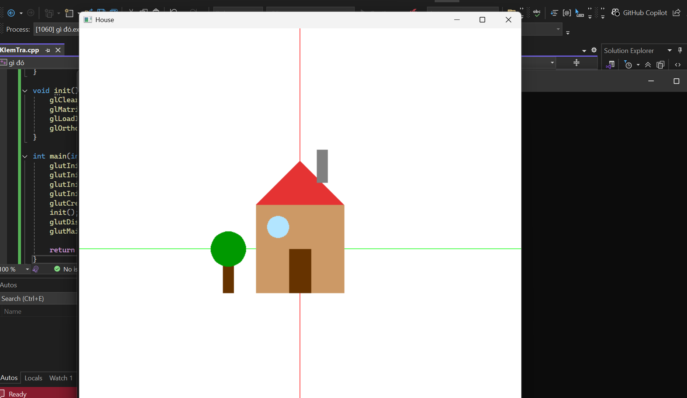
#include "glut.h"
#include <cmath>

// Hàm vẽ HCN
void drawRectangle(float width, float height) {
glBegin(GL_QUADS);
glVertex2f(0.0f, 0.0f);
glVertex2f(width, 0.0f);
glVertex2f(width, height);
glVertex2f(0.0f, height);
glEnd();
}

//Hàm vẽ hình tam giác
void drawTriangle(float base, float height) {
glBegin(GL_TRIANGLES);
glVertex2f(0.0f, 0.0f);
glVertex2f(base, 0.0f);
glVertex2f(base / 2.0f, height);
glEnd();
}

// Hàm vẽ hình tròn
void drawCircle(float radius) {
glBegin(GL_TRIANGLE_FAN);
glVertex2f(0.0f, 0.0f);
for (int i = 0; i <= 360; i += 10) {
float angle = i * 3.14159f / 180.0f;
float x = radius * cos(angle);
float y = radius * sin(angle);
glVertex2f(x, y);
}
glEnd();
}

void drawToado() {
// Vẽ trục x màu xanh lá
glColor3f(0.0, 1.0, 0.0);
glBegin(GL_LINES);
glVertex2f(-1.0, 0.0);
glVertex2f(1.0, 0.0);
glEnd();

// Vẽ trục y màu đỏ
glColor3f(1.0, 0.0, 0.0);
glBegin(GL_LINES);
glVertex2f(0.0, -1.0);
glVertex2f(0.0, 1.0);
glEnd();
}

void drawHouse() {
// Thân Nhà
glColor3f(0.8f, 0.6f, 0.4f);
glPushMatrix();
glTranslatef(-0.2f, -0.2f, 0.0f);
glScalef(0.4f, 0.4f, 1.0f);
drawRectangle(1.0f, 1.0f);
glPopMatrix();

// Mái Nhà
glColor3f(0.9f, 0.2f, 0.2f);
glPushMatrix();
glTranslatef(-0.2f, 0.2f, 0.0f);
glScalef(0.4f, 0.2f, 1.0f);
drawTriangle(1.0f, 1.0f);
glPopMatrix();

// Cửa nhà
glColor3f(0.4f, 0.2f, 0.0f);
glPushMatrix();
glTranslatef(-0.05f, -0.2f, 0.0f);
glScalef(0.1f, 0.2f, 1.0f);
drawRectangle(1.0f, 1.0f);
glPopMatrix();

// Cửa Sổ
glColor3f(0.7f, 0.9f, 1.0f);
glPushMatrix();
glTranslatef(-0.1f, 0.1f, 0.0f);
glScalef(0.05f, 0.05f, 1.0f);
drawCircle(1.0f);
glPopMatrix();

// Ống Khói
glColor3f(0.5f, 0.5f, 0.5f);
glPushMatrix();
glTranslatef(0.075f, 0.3f, 0.0f);
glScalef(0.05f, 0.15f, 1.0f);
drawRectangle(1.0f, 1.0f);
glPopMatrix();
}

void drawTree() {
// Thân Cây
glColor3f(0.4f, 0.2f, 0.0f);
glPushMatrix();
glTranslatef(-0.35f, -0.2f, 0.0f); // Di chuyển cây sang trái
glScalef(0.05f, 0.2f, 1.0f);
drawRectangle(1.0f, 1.0f);
glPopMatrix();

// Tán Cây
glColor3f(0.0f, 0.6f, 0.0f);
glPushMatrix();
glTranslatef(-0.325f, 0.0f, 0.0f);
glScalef(0.08f, 0.08f, 1.0f);
drawCircle(1.0f);
glPopMatrix();
}

void display() {
glClear(GL_COLOR_BUFFER_BIT);
glLoadIdentity();
drawToado();
drawHouse();
drawTree();
glFlush();
}

void init() {
glClearColor(1.0f, 1.0f, 1.0f, 1.0f);
glMatrixMode(GL_PROJECTION);
glLoadIdentity();
glOrtho(-1.0, 1.0, -1.0, 1.0, -1.0, 1.0);
}

int main(int argc, char** argv) {
glutInit(&argc, argv);
glutInitDisplayMode(GLUT_SINGLE | GLUT_RGB);
glutInitWindowSize(800, 800);
glutInitWindowPosition(100, 100);
glutCreateWindow("House");
init();
glutDisplayFunc(display);
glutMainLoop();

return 0;
}

